People Analytics
Flexible Dashboards Summary
v.7.0.0.7

Introduction:

We are releasing the first of several upcoming planned updates to People Analytics, focusing on the user interface and an enhanced user experience.
This document covers the following:

- General Navigation
- Dashboard Navigation
- Changing Theme
- Insights Page
- Dashboard Enhancements

All existing Dashboards will be enhanced with the new user interface as part of this release.

General Navigation:

Before this update, the General Navigation had always appeared in the top right corner of the screen:
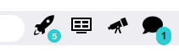

General Navigation now appears on the left-hand side of the screen, allowing for more space to display dashboard visualisations:
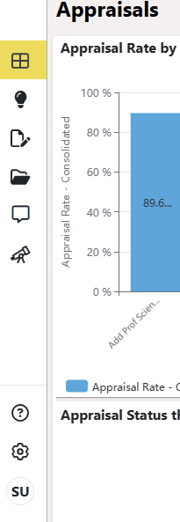

User Settings
Administration
Help
Forecasting
Message Centre
Report Packs
Report Designer
Dashboard
Insights

Dashboard Navigation:

The Dashboard navigation panel is no longer always shown, it is accessed by clicking on the Dashboard Icon and then disappears once a Dashboard is selected:

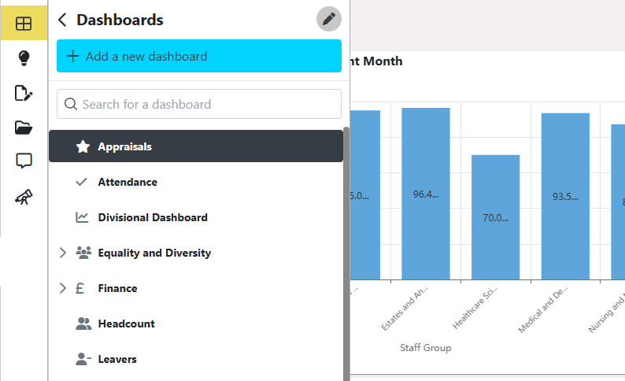

Change Theme:

The Dashboards now has a Light/Dark mode option, accessed via User Settings on the side panel:

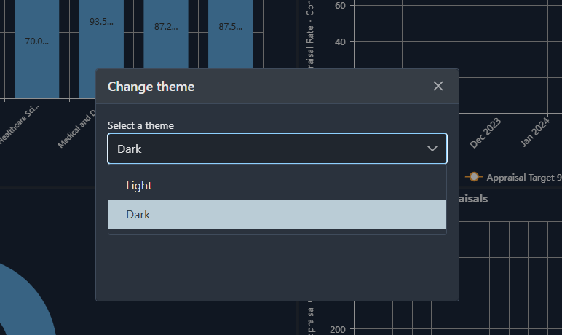
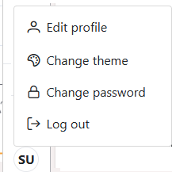

The Report Widget now lists all options under the three-dot menu as opposed to needing to be expanded:

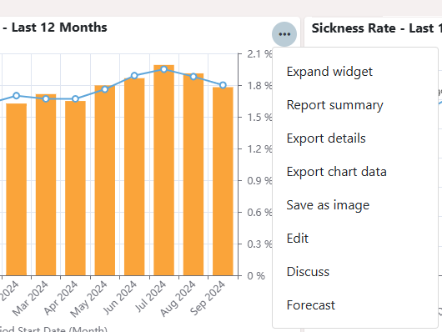

Any Dashboard Filters that are set are now hidden rather than always showing and can be expanded by clicking on the View Filters button:

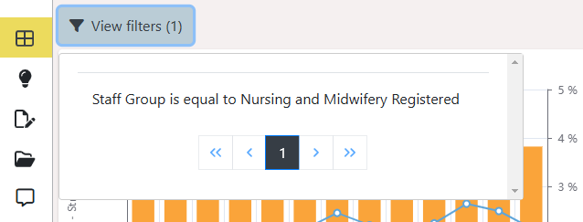

Exporting an entire Dashboard is no longer within the Dashboard navigation side panel, it is now on the top right of the screen next to the filter button:

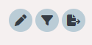

Insights Page:

The Insights page (Containing My Metrics, Action Plans, Analysers and Articles) will remain in the current system user interface style. Clicking on Insights from the side menu will open a new tab. The Insights redesign is coming in future releases.

Dashboard Enhancements:

Changes have been made to allow for increased configuration to each dashboard. This modernises the dashboard experience, improves load times and gives much more flexibility designing dashboards providing the ability to set a tiled configuration approach.

Furthermore, you can complement Dashboards with the following Widgets:

  - Images (Upload a J-Peg or PNG)
  - Metric Tiles (From Insights)
  - Text (Add titles, paragraphs or bullet points)
  - Action Plan Summary (From Insights)
  - Forecast Summary (From Forecasting Module)

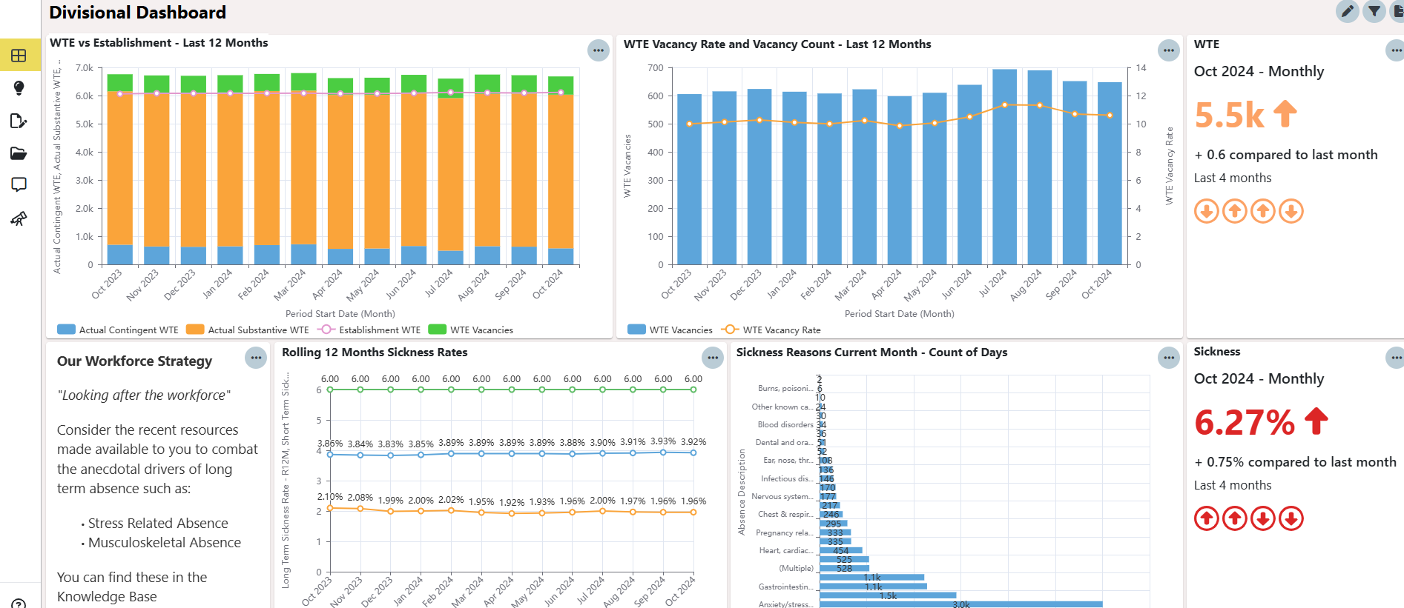

Liaison will co-ordinate and work with Product Owners in each NHS organisation post release, to review current content and utilise these new features.

